Debugging Notes

* When connecting the jetson nano, think of it like a Raspberry Pi
  + Need to connect hdmi to monitor, mouse and keyboard

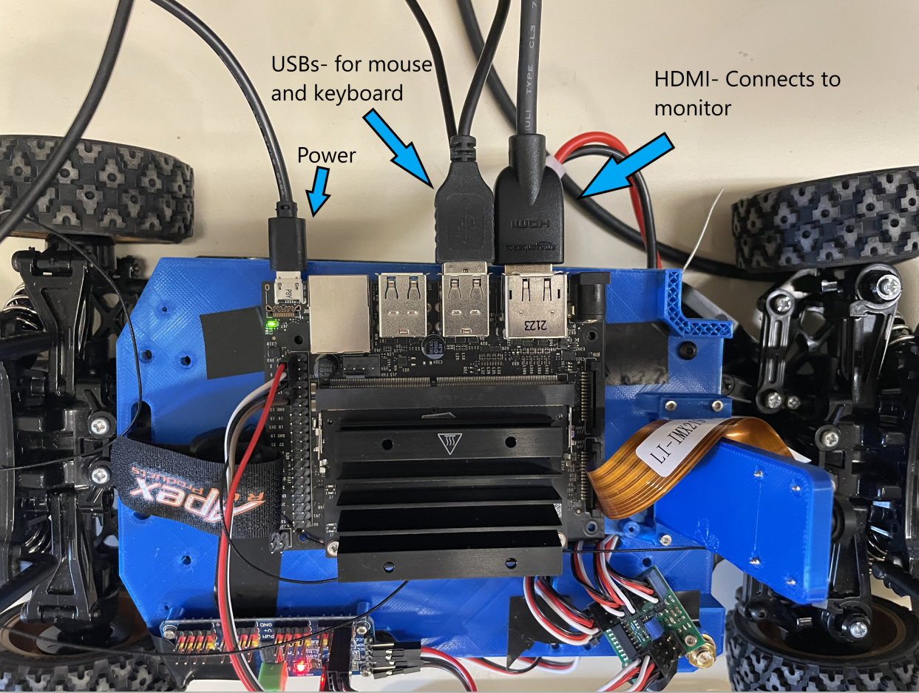

Nano connected to monitor, mouse and keyboard

* Make sure power connections are working!!
  + Turn switch on for battery and have nano connected to power supply
* There are two modes
  + Remote control mode (using transmitter)
  + Python file control (using Jupyter notebook)
* When using the transmitter, make sure the remote is connected to the receiver
  + Go to Link function on transmitter and hold the middle button (like syncing a bluetooth connection)

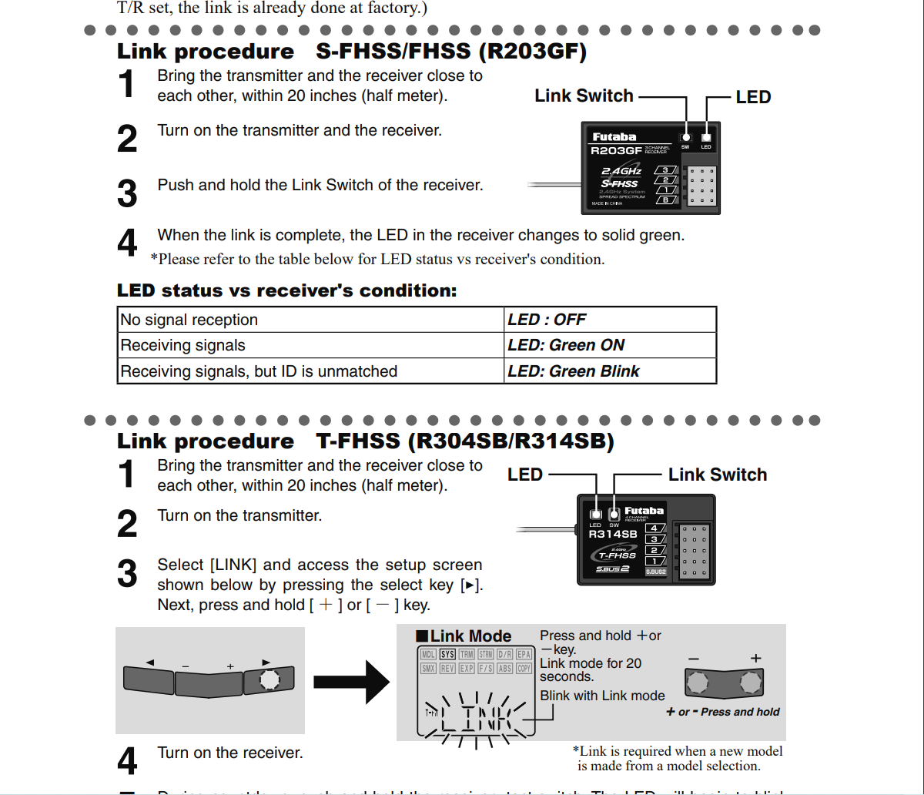

Link to transmitter manual- <https://futabausa.com/wp-content/uploads/2018/09/3PV.pdf>